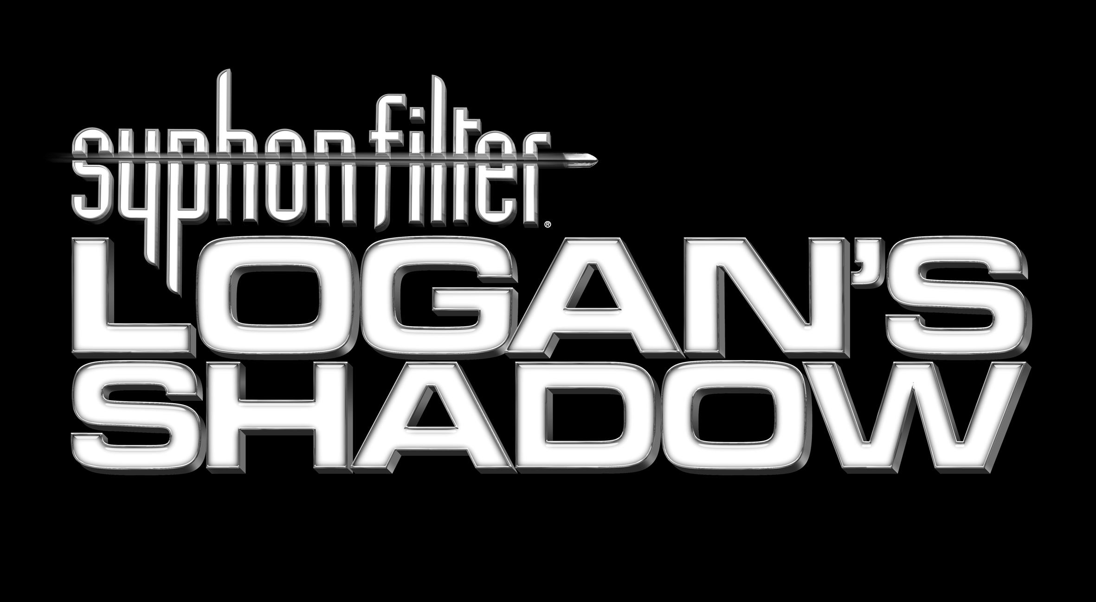

Press Information
For Immediate Release

Will Gabe Logan lose his shadow at Leipzig?
Syphon Filter™: Logan’s Shadow showcased at Games Convention

- Logan is back on the case in a brutal new tale of gunplay and espionage
- Gripping storyline by thriller novelist and DC Comics star writer Greg Rucka
- The award-winning series returns with all-new features and even more action

Leipzig, Germany, August 20-22: A piracy incident in the Indian Ocean will lead secret agent Gabe Logan on a round-the-world tour of espionage and enemy elimination in Syphon Filter™: Logan’s Shadow for PSP™ (PlayStation®Portable) – and there will be an exclusive preview at the Leipzig Games Convention this August, courtesy of Sony Computer Entertainment Europe and developers Sony Bend. The sequel to 2006’s critically acclaimed Syphon Filter: Dark Mirror, Syphon Filter: Logan’s Shadow hits shelves this October – but you can see it first at Leipzig.

Logan’s mission appears clear: to secure the contents of the ship’s Cargo Hold 5 from the Somali raiders. But, as if this operation isn’t challenging enough, Gabe is faced with the possibility that his long-term partner, Lian Xing, is a double agent. With his agency compromised and the US Government breathing down his neck, Gabe’s resolve is tested to the absolute limit; not least when he also realises that a mysterious figure is shadowing his every move… He wants answers - and he’s going to get them by doing what he does best - stealthy reconnaissance and ruthless elimination of his enemies.

In a storyline written for Syphon Filter by comic book luminary Greg Rucka, you’ll travel from the depths of the Indian Ocean to the deserts of the Middle East to prevent a revolutionary new weapon falling into the wrong hands – all the while with the mysterious agent following you in the shadows. You’ll encounter new gameplay features such as underwater combat, blind fire and grappling as well as realistic environment physics which enable you to bring down structures on top of your enemies. And, once you’ve mastered the tactics that your new weapons allow for, you can take on your friends in multiplayer Ad-Hoc Mode.

- Play a story written by a master: Logan’s Shadow is a story of political intrigue with an emotional edge, developed by DC Comics star Greg Rucka, writer of Batman, Gotham Central and Queen and Country.

- All-new gameplay features including underwater combat: explore and fight in sub-aqua environments with realistic underwater physics. Use “blind fire” to provide cover in life-threatening situations and turn enemies into human shields with the new “grapple” feature.

- Incredible new weapons: Logan’s Shadow gives you more combat options than ever before. New underwater arms including spear guns and bolt pistols bolster your arsenal of grenade launchers, sticky mines, smoke grenades and flash bangs.

Can you return a deadly weapon to safe hands, find out the truth about your colleague and shake your Shadow? Syphon Filter: Logan’s Shadow is on show at Leipzig this August – and look out for Syphon Filter: Dark Mirror for PlayStation®2 at the same event.

ENDS

For further information, please contact your local PR manager.

About Sony Computer Entertainment Europe Ltd as of 3rd July 2007

Sony Computer Entertainment Europe (SCEE), based in London, is responsible for the distribution, marketing and sales of PLAYSTATION®3, PlayStation®2 and PSP™ (PlayStation®Portable) software and hardware in 102 territories across Europe, the Middle East, Africa and Oceania. SCEE also develops, publishes, markets and distributes entertainment software for these formats, and manages the third party licensing programs for the formats in these territories. Since the launch of PLAYSTATION 3 in Europe on 23 March 2007 and the end of March 2007 over 1.6 million units have been shipped across the SCEE territories, over 5.5 million globally. Between its European debut on 24th November 2000 and the end of March 2007, over 44 million PlayStation 2 consoles have been shipped across the SCEE territories, over 117 million worldwide, making it one of the most successful consumer electronic products in history. Between its European debut on 1st September 2005 and the end of March 2007, over 8.8 million PSP systems have been shipped across the SCEE territories, with over 25 million shipped worldwide since its Japanese launch in December 2004.

More information about PlayStation products can be found at www.playstation.com or visit the Virtual Press Office at www.scee.presscentre.com.

PlayStation, PSP and the PlayStation logo are registered trademarks of
Sony Computer Entertainment Inc. PS3 and Cell Broadband Engine trademarks of Sony Computer Entertainment Inc. All other trademarks are property of their respective owners.

